AvanzeAPI Process Documentation
Open AvanzeAPI using the URL given below:
https://apistage.direct2title.com
LOGIN:
- If you are already a user of AvanzeAPI then enter your e-mail and password and click on SIGN IN button.
- If you are entered a wrong password or email id it will show an error like Invalid Username or Password.
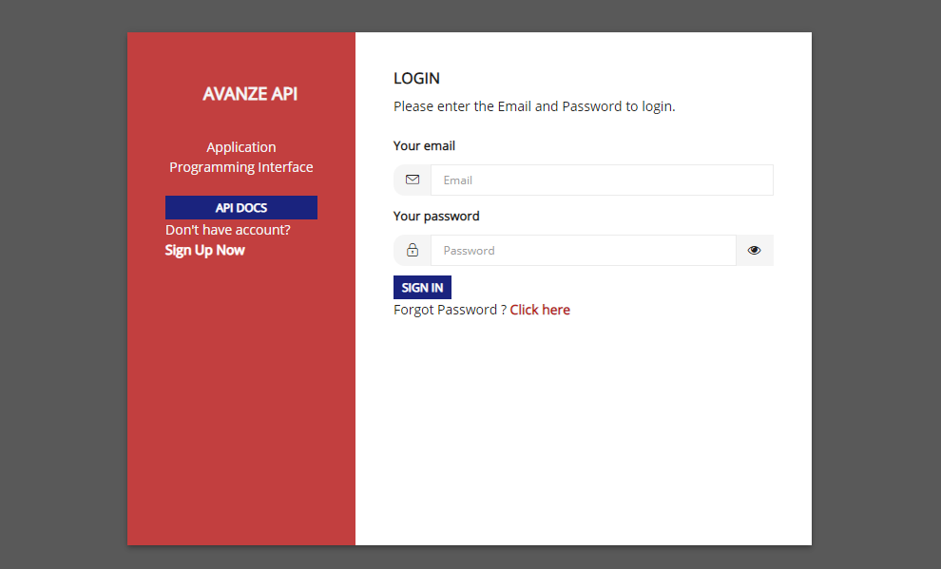
SIGN UP:
- Click on Sign Up Now button.
- Enter the basic details.
- In that password must contain at least one uppercase letter, one lowercase letter, one numeric letter and also one special character.
- Choose whether you are a lender or vendor and check the checkbox and click on SIGN UP button.
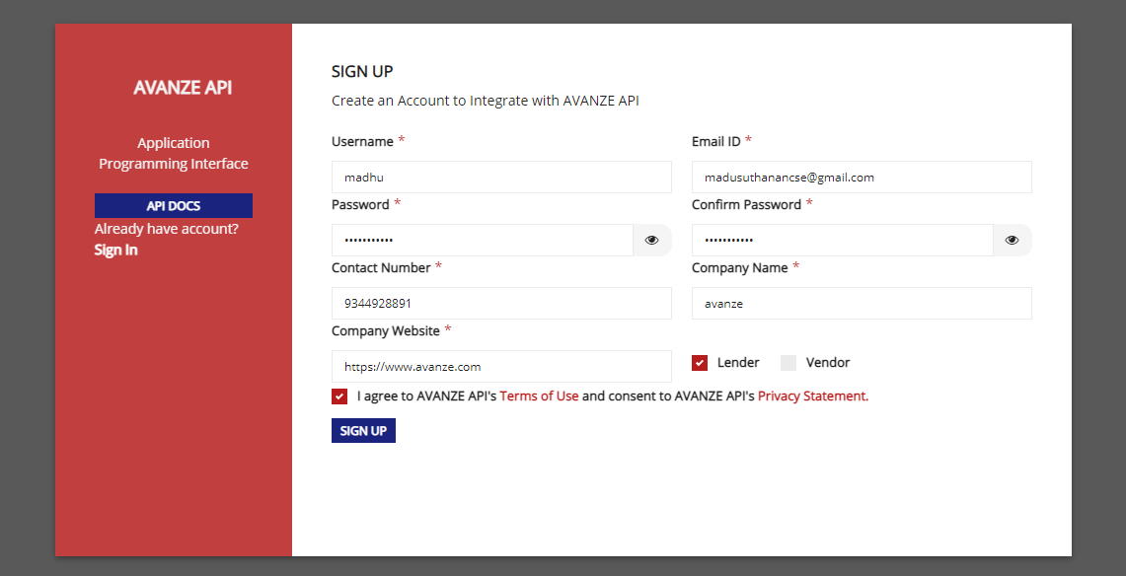
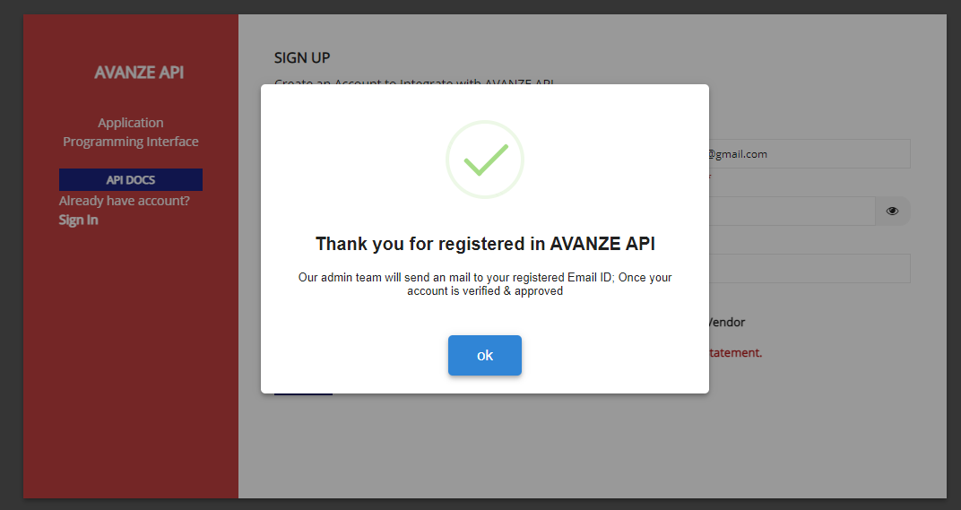
- Once you registered, an e-mail will be send to the admin team for approval of the registered user.
- If the admin team is not approved you cannot login into your account.
- Instead you will be getting an error like Your Account is not approved.

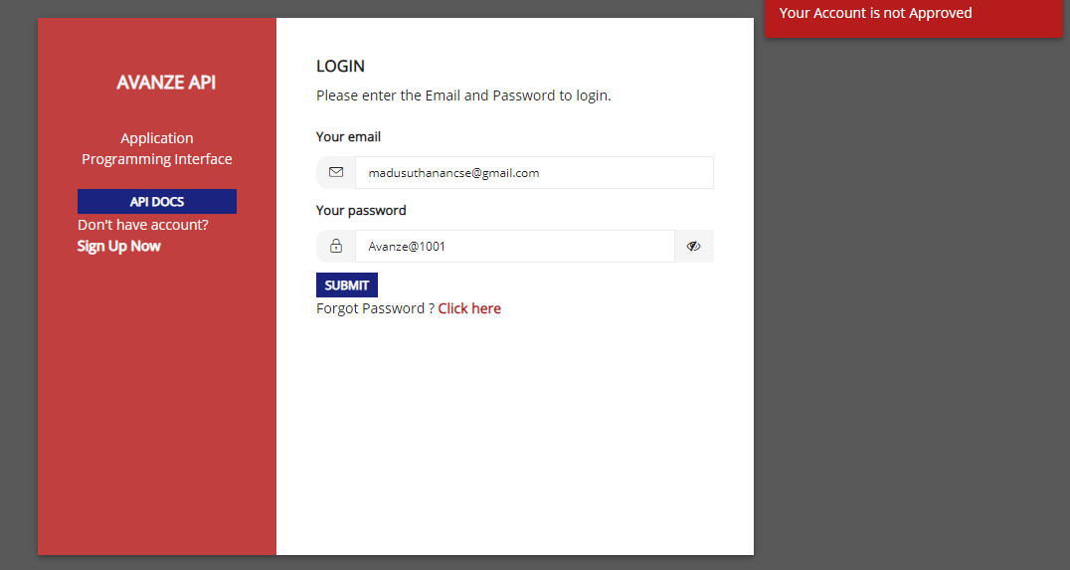
- Now the admin team will be approving the user by giving some of the permission.
- Once the admin team is approved the registered e-mail will be getting a notification based on the approval (i.e Your account is approved).
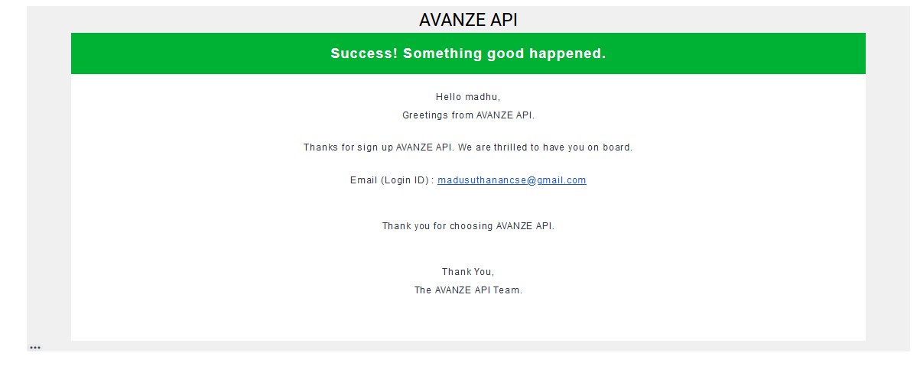
- Once your account is approved then you can login by entering your registered mail id and password.
- If the admin approved your account by enabling force reset you will be redirecting to force reset page.
- In that you can reset your password by entering the password whatever you want and also enter the same password in confirm password field also.
- After entering that, click on Reset button.
- Now you will be redirecting it to the Sign in page.
- You can login by entering the registered e-mail and the password created by you.
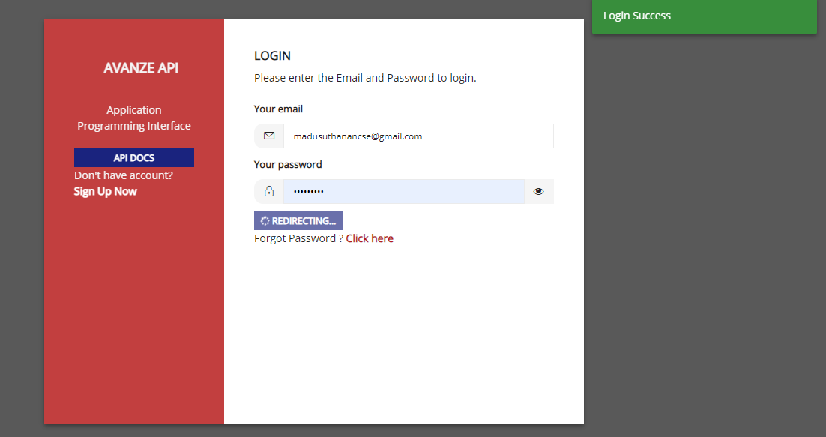
- Once you have been logged in you will be redirected to the home page of AvanzeAPI.
- In that page you can see the master setup based on the permission given to your account by the admin team.
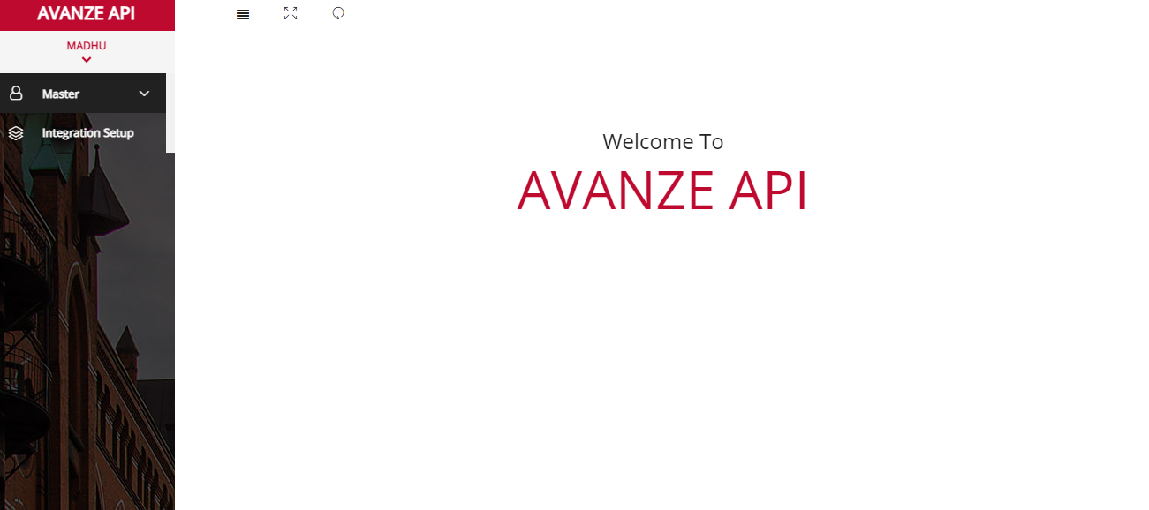
FORGOT PASSWORD:
- If you have forgotten you password, you can update the password by clicking on Forgot password link in the login page.
- If you click on forgot password, it will redirect it to forgot password page.
- In that you need to enter your e-mail that you have been used while registering.
- After entering your e-mail click on SEND REQUEST button.
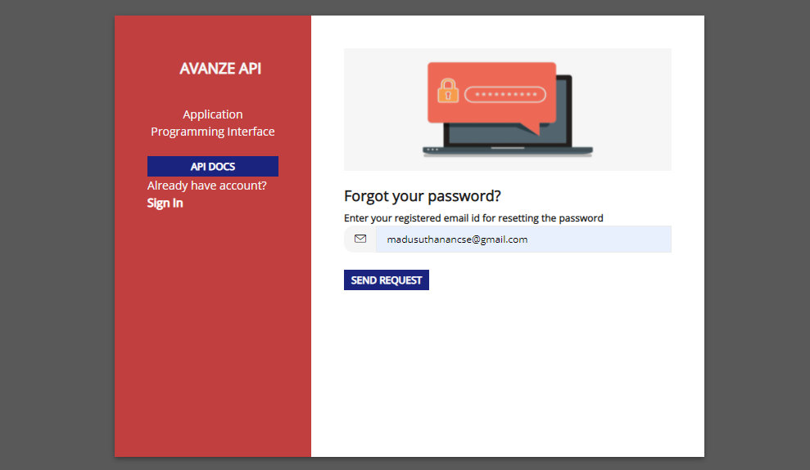
- A request will be received for that entered e-mail with one Dynamic Access Code and reset password link.
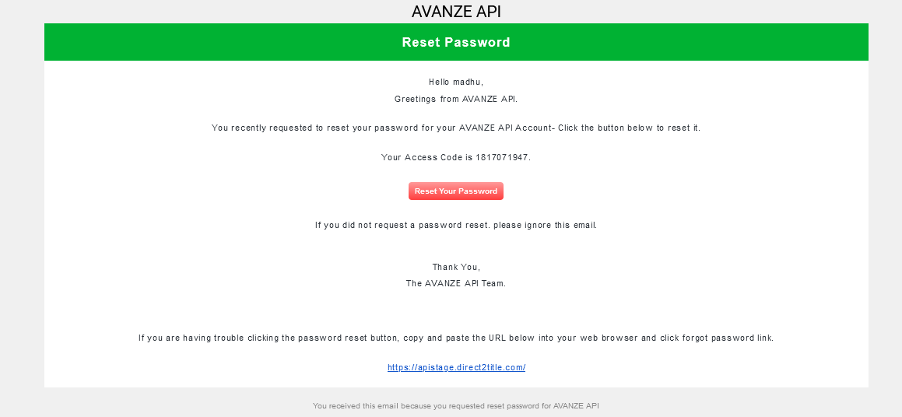
- You can use the link which you have got through e-mail or else you can use the AvanzeAPI page also to update your password.
- If you click on Reset Password button it will be redirect it to update password page.
- In that page enter the Access code which you have been received through the mail, and also enter the new password for your account.
- Now click on SUBMIT button to update your password.
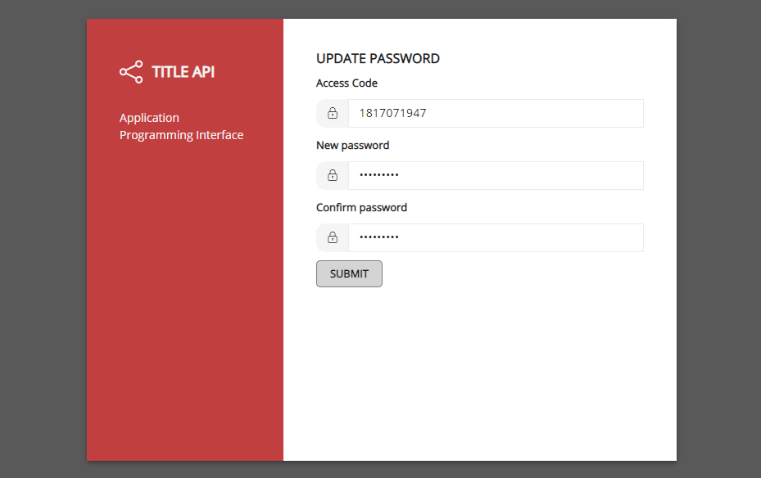
- Once your password update is done, it will be redirect it to the login page.
- Now you can login into your account by using the e-mail id and the updated password.
Integration Setup:
- After logged in into your account, click on Integration Setup under master module.
- In that page, Post URL and some basic setup details will be displayed along with 0% of progress bar.
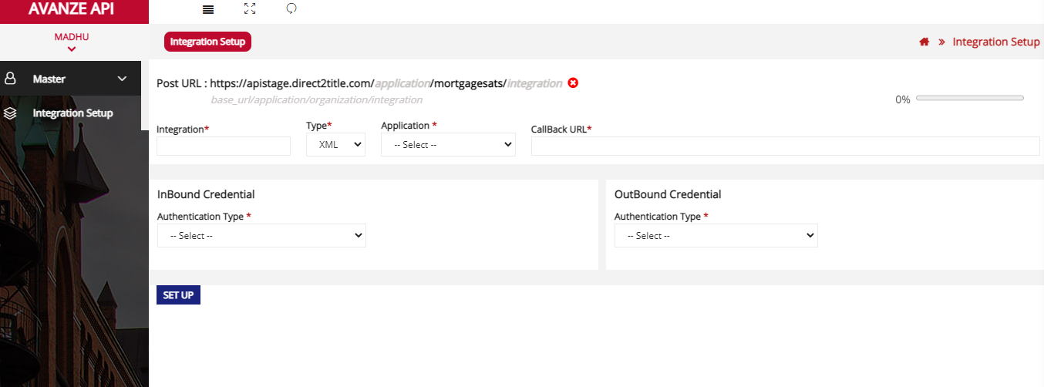
- Post URL is validated based on some fields in the Integration Setup.
Example: (base_url/application/organization/integration).
- Progress bar is displayed based on three ways:
  - Initially it will be 0%.
  - If you complete the basic setup details it will reach to 50%.
  - If you complete the client setup also it will reach to 100% and a message is displayed as Ready to place Order.
- Fill the basic integration details like Integration name, application, data type, callback url, Inbound and Outbound credentials and click on Setup button.
- Now the progress change to 50% and Client setup will be displayed.
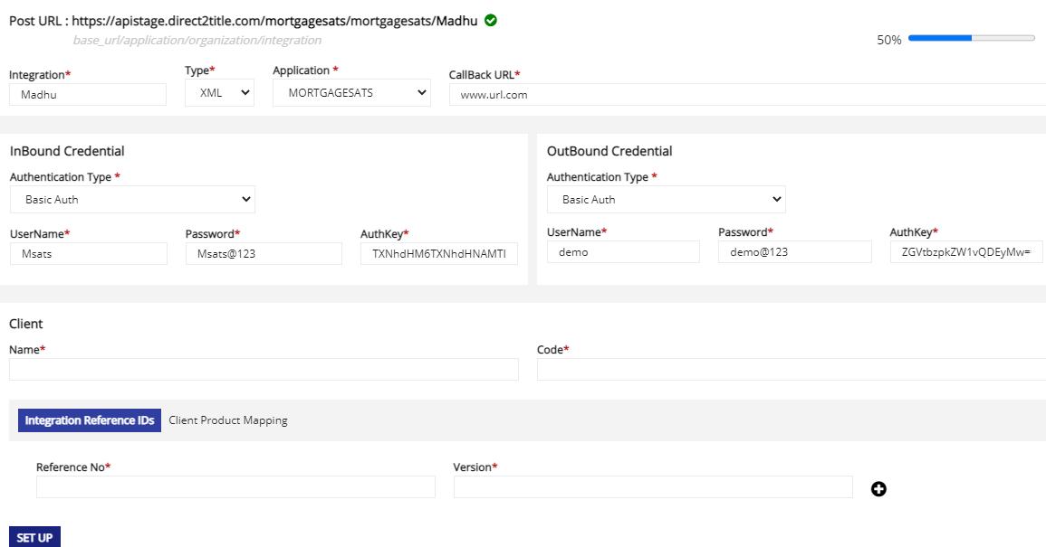
- Fill all the client details, client reference details and also product mapping details for that client integration.
- Click on Client Product mapping tab. In that client is loaded based on the organization chosen for that user.
- Based on the selection of Client Product field is loaded.
- Based on the product field sub product field is loaded.
- After entering all the mandatory fields click on SET UP button.
- Now the Progress is changed to 100% and a message is displayed as Ready to Place Order.
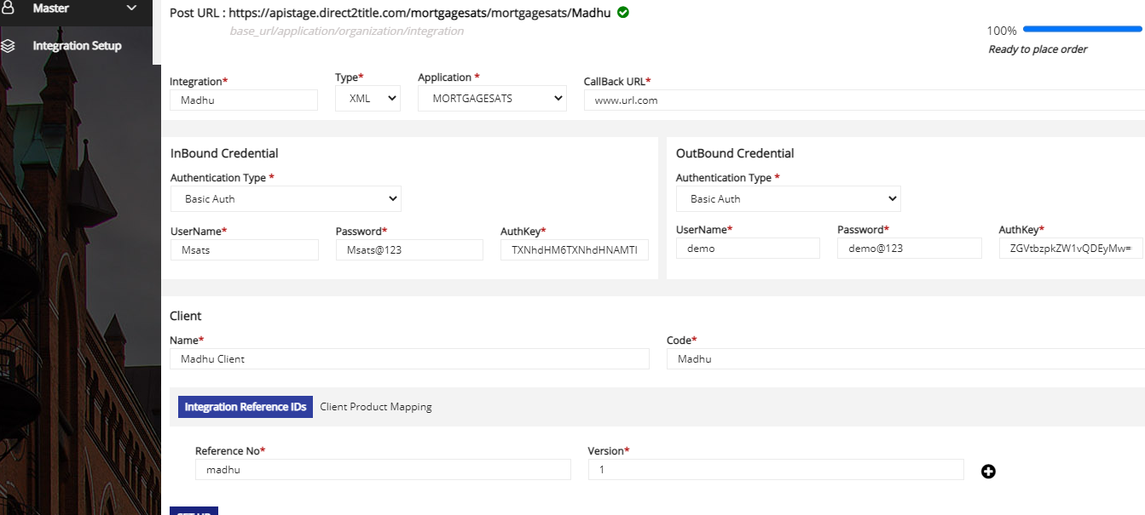
- After completing this process you are ready to process the integration.

